Worksheet 1: Memory Layout & Performance

Objective
Understand how data layout affects memory access patterns and performance.
Predict performance outcomes before measuring them.

Part A: Prediction
Study the two data layouts below. Predict which layout will perform better when iterating over the position values only.
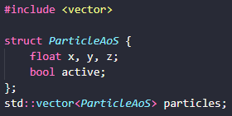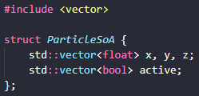

Question 1:
Which Layout do you expect to perform better when iterating over positions only? Why?
____________________________________________________________________________________________________________________________________________________________________________________________________________________________________________________________________________________________________________________________________________________________________________________________________________________________________________________________________________________________________________________________________________________________________________________________________________________________________________________________________________________________________________________________________________________________________________________________________________________________________________________________________________________________________________________________________________________________________________________________________________

Part B: Observation
Run the provided benchmarks
- aos_iteration
- soa_iteration

Record
Benchmark | Execution Time | Cache Miss Statistics
aos_iteration
soa_iteration

Part C: Reflection
- Did the observed results match your prediction?
___________________________________________________________________________________________________________________________________________________________________________________________________________________________________________________
- Which memory effects explain the difference?
_____________________________________________________________________________________________________________________________________________________________________________________________________________________________________________________________________________________________________________________________________________________________________________________________________________________
- How might this influence real system design?
_______________________________________________________________________________________________________________________________________________________________________________________________________________________________________________________________________________________________________________________________________________________________________________________________________________________________________________________________________________________________________________________________________________________________________________________

